**PIZZA SALES SQL QUERIES**

**A. KPI’s**

**1. Total Revenue:**

select SUM(total_price) as Total_revenue from pizza_sales

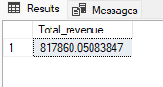

**2. Average Order Value**

select sum(total_price)/count(distinct order_id) as avg_order_value from pizza_sales

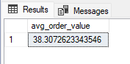

**3. Total Pizzas Sold**

select sum(quantity) as Total_Pizza_sold from pizza_sales

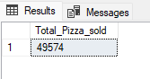

**4. Total Orders**

select count(distinct order_id) as total_orders from pizza_sales

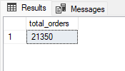

**5. Average Pizzas Per Order**

select cast(cast(sum(quantity) as decimal(10,2))/

cast(count(distinct order_id) as decimal(10,2)) as decimal(10,2)) as avg_pzza_order

from pizza_sales

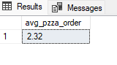

**B. Daily Trend for Total Orders**

select DATENAME(dw,order_date) as order_day,count(distinct order_id) as total_orders

from pizza_sales

group by DATENAME(dw,order_date)

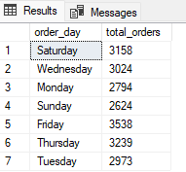

**C. Monthly Trend for Orders**

select DATENAME(month,order_date) as Month_name , count(distinct order_id)

as total_orders

from pizza_sales

group by datename(month,order_date)

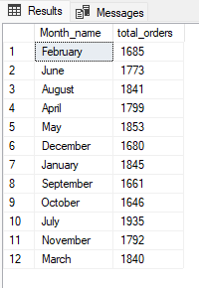

**D. % of Sales by Pizza Category**

select pizza_category, cast(sum(total_price) as decimal(10,2))as total_revenue,

cast(sum(total_price)*100/ (select sum(total_price) from pizza_sales)

as decimal(10,2)) as pct

from pizza_sales

group by pizza_category

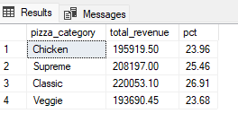

**E. % of Sales by Pizza Size**

select pizza_size,cast(sum(total_price) as decimal(10,2)) as total_revenue,

cast(sum(total_price)* 100/ (select sum(total_price) from pizza_sales)

as decimal (10,2)) as PCT

from pizza_sales

group by pizza_size

order by pizza_size

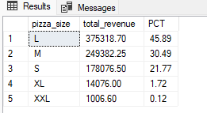

**F. Total Pizzas Sold by Pizza Category**

select pizza_category,sum(quantity) as total_quantity_sold

from pizza_sales

where month(order_date)=2

group by pizza_category

order by total_quantity_sold DESC

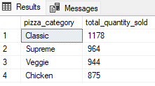

**G. Top 5 Pizzas by Revenue**

select top 5 pizza_name,sum(total_price) as total_revenue

from pizza_sales

group by pizza_name

order by total_revenue DESC

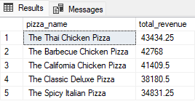

**H. Bottom 5 Pizzas by Revenue**

select top 5 pizza_name,sum(total_price) as total_revenue

from pizza_sales

group by pizza_name

order by total_revenue ASC

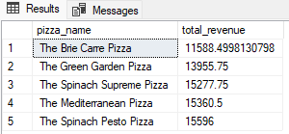

**I. Top 5 Pizzas by Quantity**

select top 5 pizza_name,sum(quantity) as total_pizza_sold

from pizza_sales

group by pizza_name

order by total_pizza_sold DESC

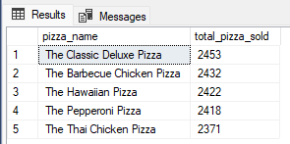

**J. Bottom 5 Pizzas by Quantity**

select top 5 pizza_name,sum(quantity) as total_pizza_sold

from pizza_sales

group by pizza_name

order by total_pizza_sold asc

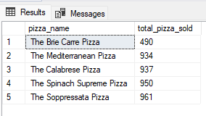

**K. Top 5 Pizzas by Total Orders**

select top 5 pizza_name,count(distinct order_id) as total_orders

from pizza_sales

group by pizza_name

order by total_orders DESC

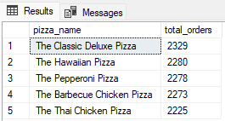

**L. Bottom 5 Pizzas by Total Orders**

select top 5 pizza_name,count(distinct order_id) as total_orders

from pizza_sales

group by pizza_name

order by total_orders ASC

